Title Should Be in Bold, 14-Point Type and Centered; Please Use Title Case

Author name(s) and affiliation(s) [Author¹, Author², and Author³]
line 1 (of Affiliation(s)) – dept./name of organization
line 2 – name of organization, acronyms acceptable
line 3 – city, country
line 4 – e-mail address of the corresponding author

Abstract—This file is a full-abstract template for Compound Semiconductor Week (CSW) 2027 to be held in Venice, Italy. CSW2027 is a joint venue for the 53nd International Symposium on Compound Semiconductors (ISCS) and the 38th International Conference on Indium Phosphide and Related Materials (IPRM). CSW2027 aims to be the premier forum for science, technology, and applications in all areas of compound semiconductors. This short abstract – in bold 9-pt Times New Roman font – should be a concise summary of the paper.
Keywords—keyword1; keyword2; keyword3

Introduction
The full abstract for CSW ISCS/IPRM 2027 should be submitted as a PDF file. Use ISO A4-format with margins of 1 inch on all sides. Please embed all fonts in the PDF abstract file. You are strongly encouraged to use this MS Word template for preparing the abstract to ensure conformity to all formatting guidelines as incorrectly-formatted abstracts will be rejected by the submission website.

Style Guide
The first page should be used for text and should include the abstract title, short abstract, list of authors, affiliations, main text, and references. The contact information of the corresponding author should follow the list of authors. The abstract title should be in bold 14-pt Times New Roman font. The short abstract should be in bold 9-pt Times New Roman font. The main text should be in 10-pt Times New Roman font. References to prior work, if any, should be given at the end of the text page in 8-pt Times New Roman font and left-aligned.
The second page should be reserved for figures and tables. All figures and tables should be clearly labeled and captioned (8-pt font) so that they can be understood independent of the text.
To typeset equations, use Equation (Word 2007 or later) or MathType.
$f\left(x\right)=a_{0}+\sum_{n=1}^{∞}{\left(a_{n}\cos{\frac{nπx}{L}}+b_{n}\sin{\frac{nπx}{L}}\right)}$ (Equation)
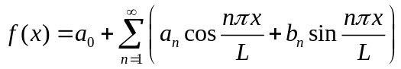 (MathType)
Abstracts that do not follow these formatting rules will be automatically rejected.

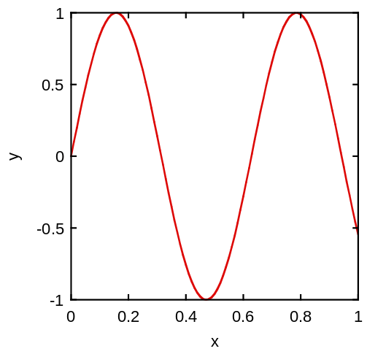
Fig. 3. Test figure

Fig. 2. Test figure
Table 1. Test table
Test | Table | Value
1 | 5 | 9
2 | 6 | 10
3 | 7 | 11
4 | 8 | 12

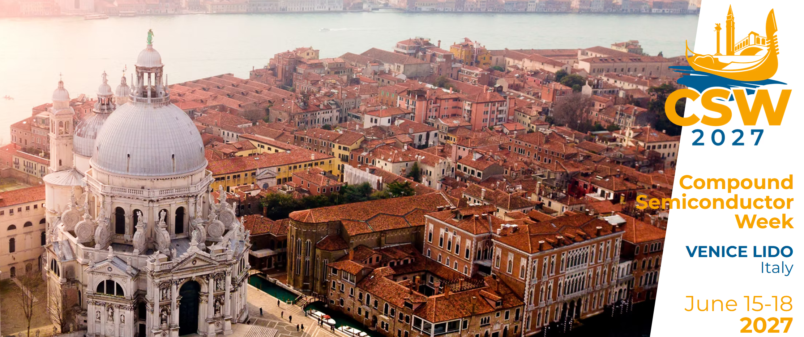
Fig. 1. Test figure.

